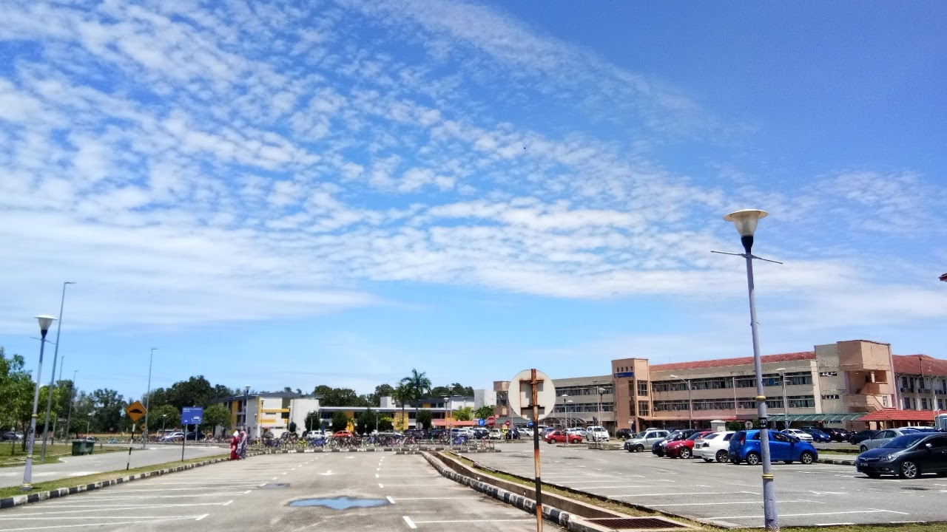

Mesmerizing view of The Administration and Academic Building

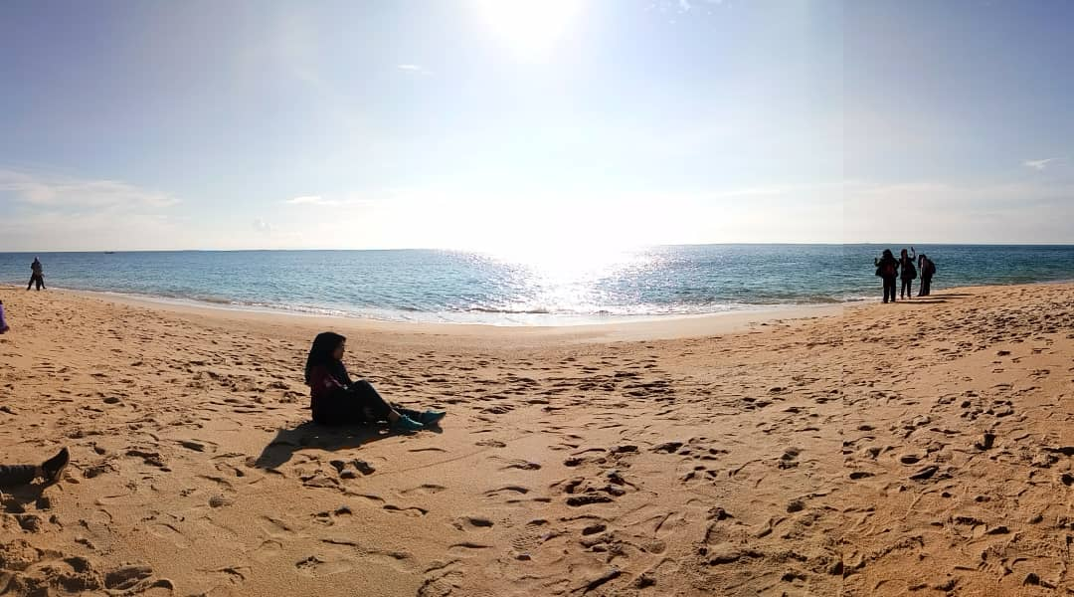

Sunrise at Teluk Mayat, located in the UiTMCT Dungun’s authority

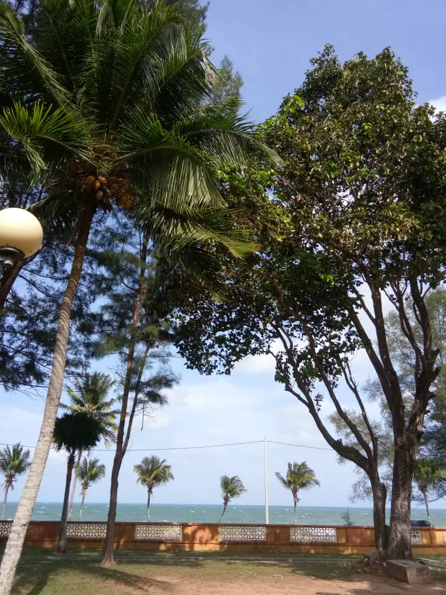

Front view of the sea side from Block 15 of UiTMCT Campus of Dungun



Aeerial Overhead Shot of UiTMCT Campus of Dungun

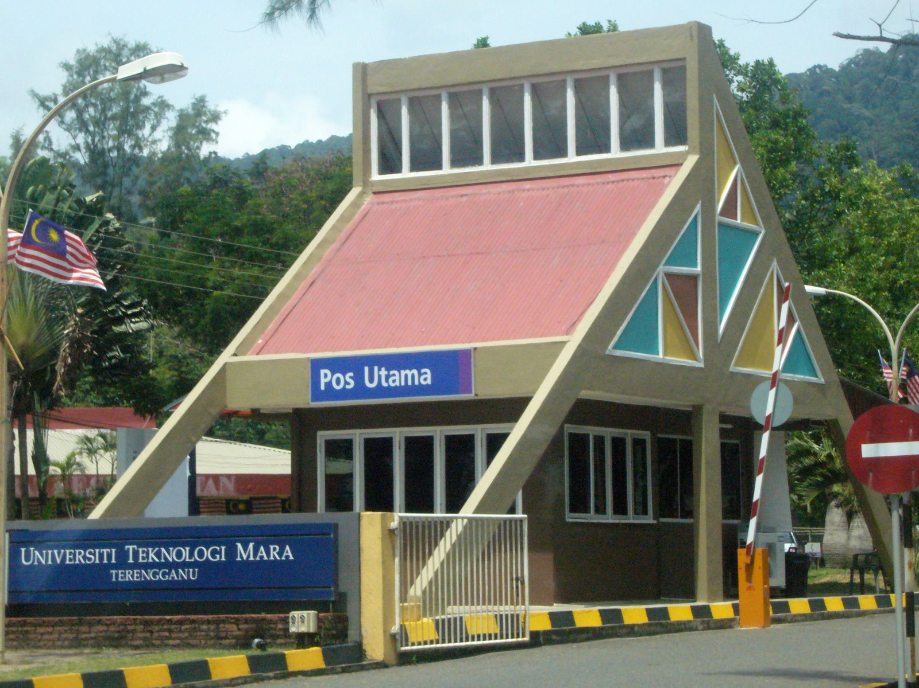

Main Gate of UiTMCT Campus of Dungun